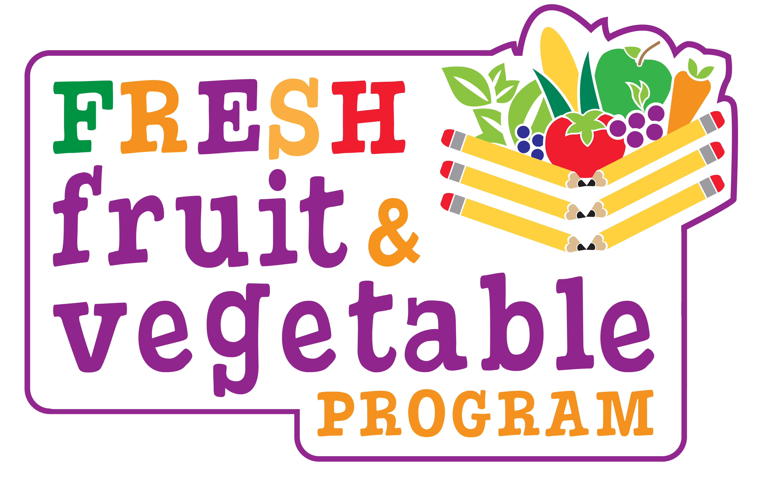

### *SAMPLE*

Dear Parents/Guardians:

Our school will be participating in a special **Fresh Fruit and Vegetable Program** for the 2024-2025 school year. **We will be offering fresh fruits and vegetables as snacks.** We are excited to have been awarded this grant to provide our ***_(Name of School)_*** students with healthy, nutritious foods. **The NJ Department of Agriculture awarded this program to only 190 schools throughout the state.**

***_(# of Days)_* days each week your child or children will enjoy a fruit or vegetable.** Occasionally, there will be **information and recipes** sent home for you as a family to participate in promoting and increasing your consumption of fruits and vegetables.

Please try to extend your child’s/children’s fruit and vegetable experience by **encouraging fruits and vegetables at mealtimes and for snacks.** Your participation will contribute to the success of this project!

**The goals of the fruit and vegetable program are as follows:**

* Increase children’s fruit & vegetable consumption.
* Create healthier schools.
* Promote wellness.
* Encourage nutritious food choices to have an impact on future health.

We hope you will extend our goals among your family and promote fruits and vegetables at home. Thank you for your support!

**Remember --- Eat More Fruits and Vegetables Everyday!**

__________________________

**Principal**